**DAILY ONLINE ACTIVITIES SUMMARY**

|  |  |  |  |  |  |  |  |  |
| --- | --- | --- | --- | --- | --- | --- | --- | --- |
| **Date:** | 09-06-2020 | | | | | **Name:** | Anvitha H M | |
| **Sem & Sec** | 4th ‘A’ | | | | | **USN:** | 4AL18CS010 | |
| **Online Test Summary** | | | | | | | | |
| **Subject** | | N/A | | | | | | |
| **Max. Marks** | | N/A | | **Score** | | | N/A | |
| **Certification Course Summary** | | | | | | | | |
| **Course** | Introduction to digital marketing. | | | | | | | |
| **Certificate Provider** | | | Great learning academy | | **Duration** | | | 5.5 hours |
| **Coding Challenges** | | | | | | | | |
| **Problem Statement:**  Program in C to generate all the set partition of N number beginning from 1 and so on. | | | | | | | | |
| **Status:** Executed | | | | | | | | |
| **Uploaded the report in Github** | | | | | YES | | | |
| **If yes Repository name** | | | | | <https://github.com/alvas-education-foundation/Anvitha-H-M> | | | |
| **Uploaded the report in slack** | | | | | Yes | | | |

**Online test:**

N/A

**Certification course:**

Introduction to digital marketing

The course gave brief information about Ad set up guide, what is custom audience and types of ads in order of attract the audience.

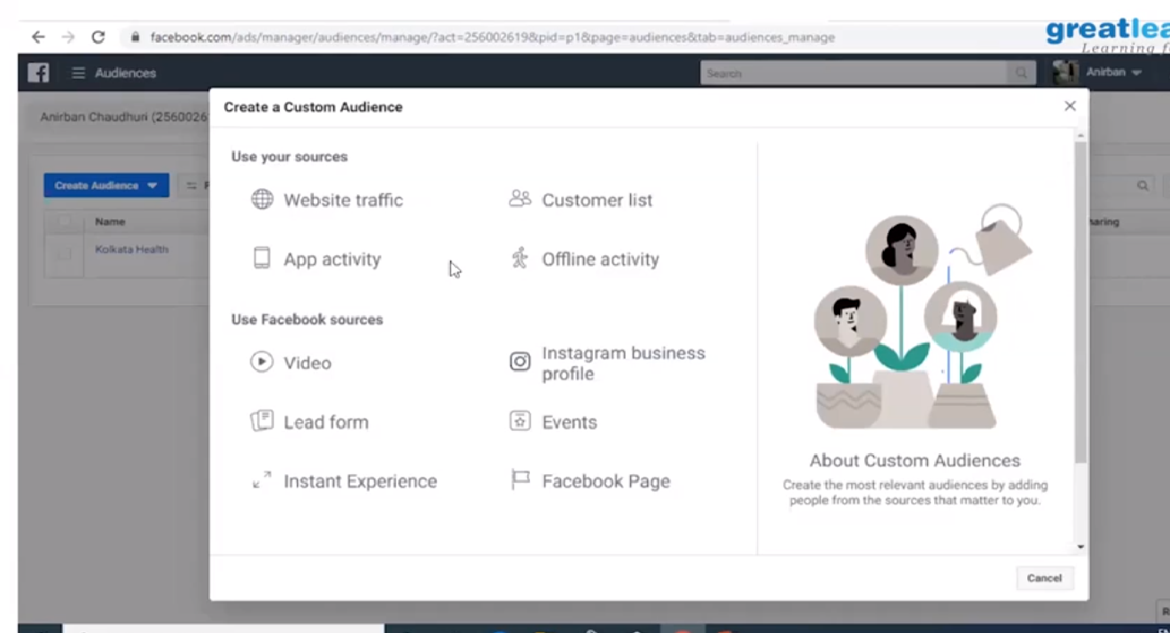

Online coding challenge

The programing statements of the day is “program in C to generate all the set partition of N number beginning from 1 and so on”.

Solution: Executed and uploaded in Github repository.

Link: <https://github.com/alvas-education-foundation/Anvitha-H-M>

